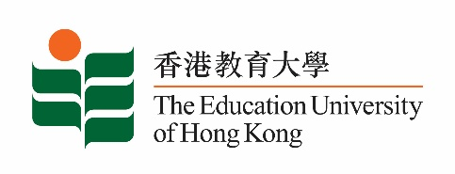
致： 传媒机构采访主任 (共 1页) 6 November 2020
To : News Editors (total: 1 page)

香港教育大学2020年11月9至22日可供采访之活动一览
The Education University of Hong Kong (EdUHK) Events Calendar for 9 to 22 November 2020
本校诚邀 贵机构派员采访下列活动。传媒查询，请联络教大传讯处（电话：2948 6050）。
You are cordially invited to cover the events below. For media enquiries, please contact the Communications Office at 2948 6050.

因应2019冠状病毒疫情，以下活动或有人数限制，传媒请预先向主办部门登记。
In light of the COVID-19 pandemic, there may be restrictions on the number of participants for the following event(s). Please contact the respective organiser(s) / department(s) for prior registration.

- 教大大埔校园 （新界大埔露屏路十号） / EdUHK Tai Po Campus (10 Lo Ping Road, Tai Po, New Territories)

日期  Date | 时间  Time | 活动  Event | 地点  Venue | 主办部门及公众查询  Organiser &  Public Enquiry | 备注  Remarks
2020-11-21 | 2 - 4 pm | 新高中视觉艺术科应试策略讲座  Seminars on DSE Visual Arts Exam Strategies 2020  讲者 / Speaker:  刘仲严博士、谭祥安博士、Laurence James Wood教授、黄素兰博士、顺德联谊总会梁銶琚中学陈蔚芝老师、教大学生  Dr Lau Chung-yim, Dr Thomas Tam Cheung-on, Professor Laurence James Wood, Dr Wong So-lan, Ms Chan Wai-chi from Shun Tak Fraternal Association Leung Kau Kui College, EdUHK students | 在线讲座  ZOOM | 主办部门 / Organiser:  文化与创意艺术学系  Department of Cultural and Creative Arts  查询 / Enquiries:  罗小姐 Miss Law  电邮 / Email:  lawsy@eduhk.hk  电话 / Tel: 2948 8735 | 免费报名，欢迎各界人士参加。  Free Registration. All are welcome.  报名方法 / Registration： https://anonmachg2.eduhk.hk/machform/view.php?id=29700725  截止报名日期 / Deadline：2020-11-15

